**CS 246 A5 Monopoly Plan of Attack**

**By: Xiaowei Wang, Xinyu Chen, Zhiyang Zhang**

1. **Day-to-day plan**

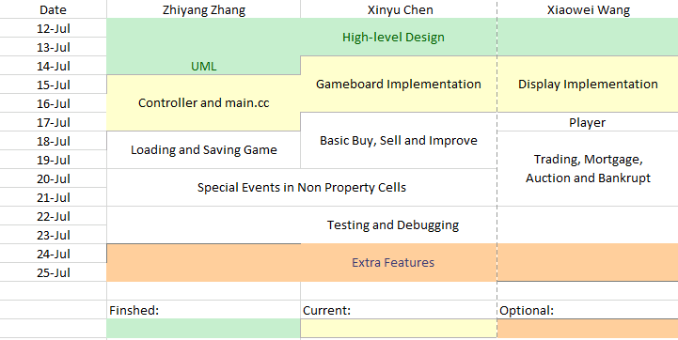

1. **Assignment Questions**

* **Question1. After reading this subsection, would the Observer Pattern be a good pattern to use when implementing a gameboard? Why or why not?**

- Yes, Observer pattern will be a good pattern to use when implementing gameboard. Gameboard can be the publisher to modify the data, and the class observer would be the observer. The cell, player and display will be the derived class from the class observer. Also, Using the observer pattern will allow for a more efficient update when implementing gameboard. Rather than generating a new gameboard, we can simply modify the gameboard by using “notify” method. For example, when a player moves, the gameboard will notify the cell and display the move.

* **Question2. Suppose that we wanted to model SLC and Needles Hall more closely to Chance and Community Chest cards. Is there a suitable design pattern you could use? How would you use it?**

- We choose to use Singleton Pattern.

The SLC and Needles Hall models are relevantly independent, and doesn’t have much relation to other classes. Also, their usages are similar and simple. The movements(SLC) or the change of the amount of a player’s savings(Needles Hall) are affected only by the result of random number generation. Then we use the random generated result to get SLC or Needles Hall’s event outcome. Therefore, we choose Singleton Pattern to simplify the structure and it will increase the efficiency.

* **Question3. Is the Decorator Pattern a good pattern to use when implementing Improvements? Why or why not?**

- No, decorator pattern is not a good pattern to use when implementing improvements. The major difference between different tuition levels of improvements is only the change of amounts of money. It is not worth using decorator pattern here since this pattern usually works well for various add-on.